开发环境搭建

Eclipse工程配置
    - 导入工程文件,file->import.
    - 选择工程类型,选定完成后,效果见下图1
然后点击Next,进入下图2界面.
    - 点击Browse,找到工程文件,toolchain
类型选择none,点击finish完成工程导
入工作.

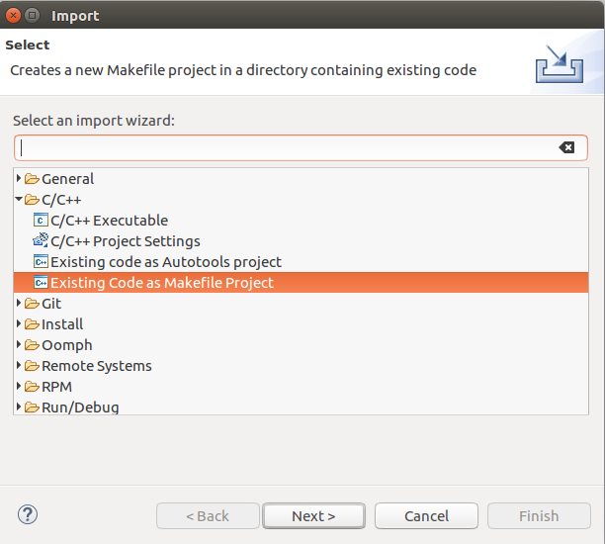
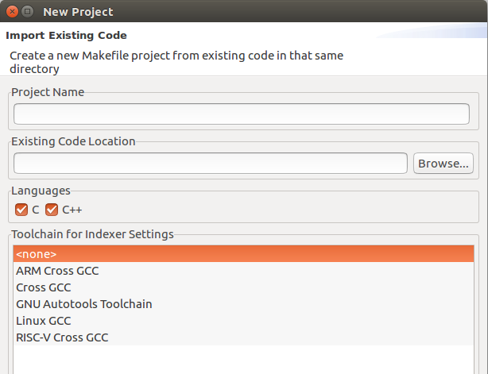
图1 图2

调试环境搭建
    - Help->eclipse marketplace在搜索栏搜索”mcu”如下图3
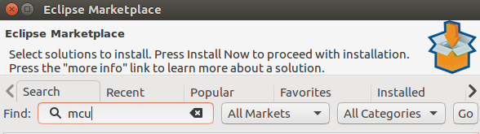
图3

    - 安装GNU MCU Eclipse4.4.1(有新版也可以)
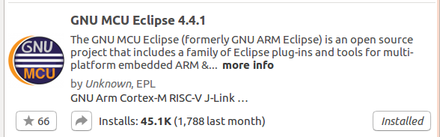

图4

    - 点击debug configurations(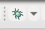就是这个小甲壳虫旁边的倒三角),如果上一个步骤安装成功,就能在debug configurations的对话框中看到GDB SEGGER J-Link Debugging.
    - 然后选中GDB SEGGER J-Link Debugging,右键new(双击也可以),出现下面界面.
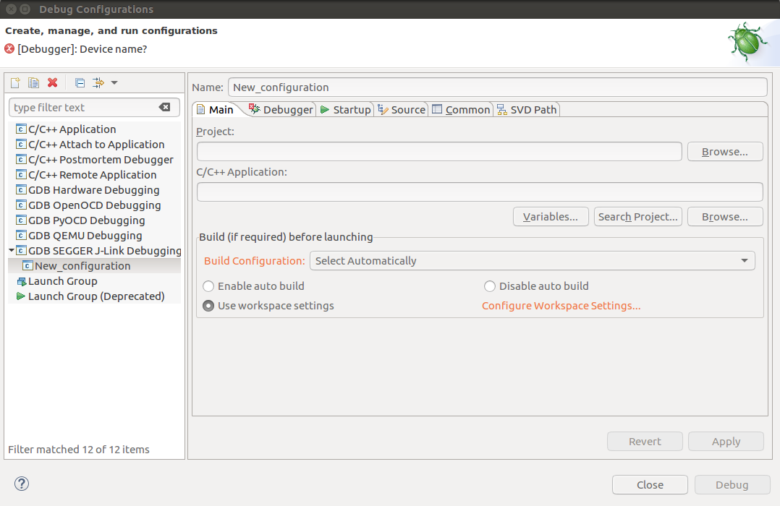
图5
    - 接下来每个选项卡的配置细节如下:
- Main选项卡
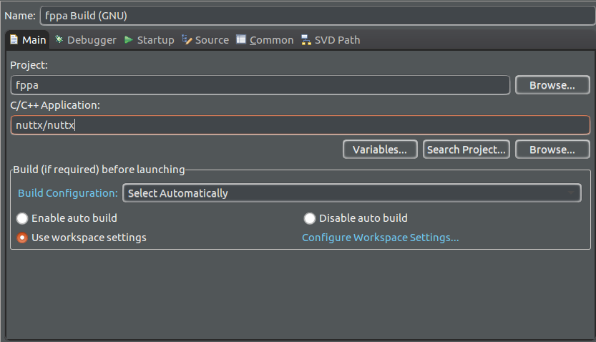

- Debugger选项卡
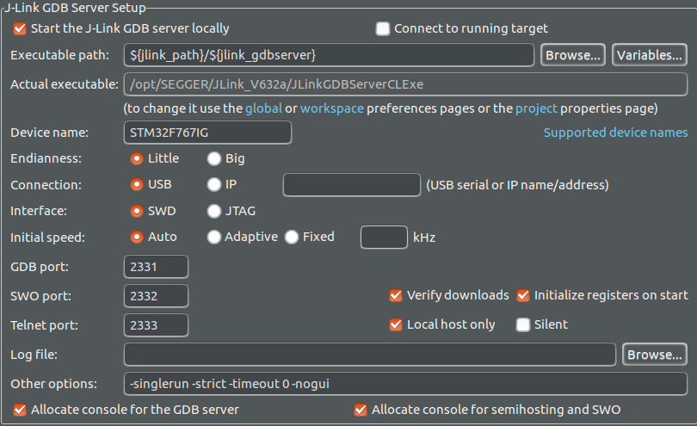
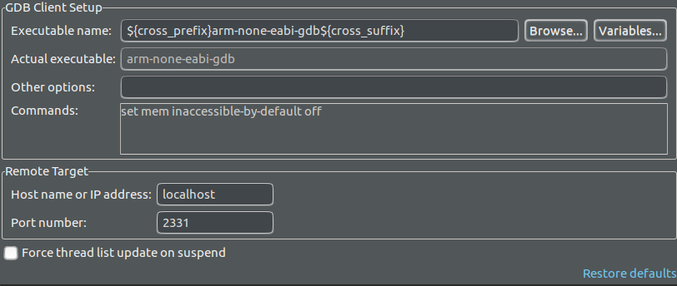

- Startup选项卡
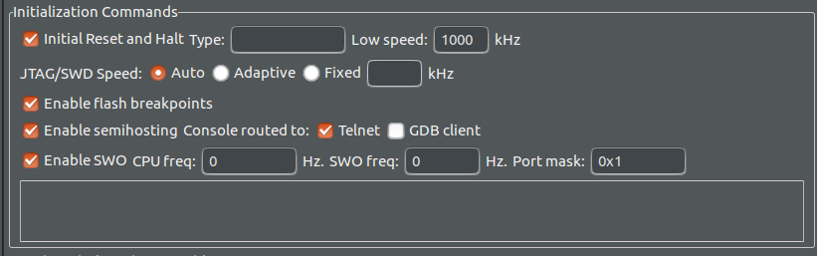
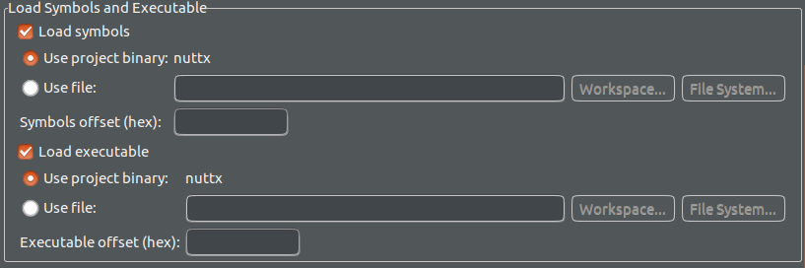
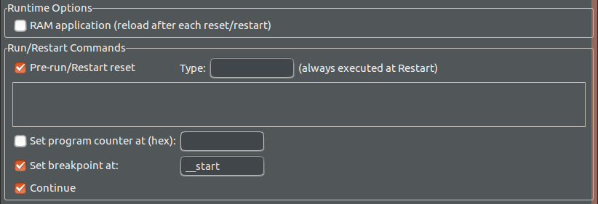

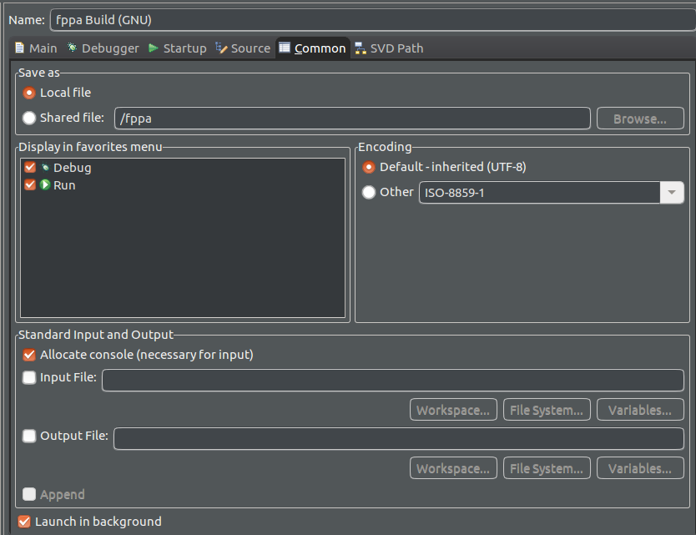
- Common选项卡

剩下的选项卡就不用填写了,到此调试环境配置完成.

新增加新board[fppa]

功能开启

打开Tab命令补全功能
> Application Configuration
> System Libraries and NSH Add-Ons
> readline() Support
[*] Echo character input
[*] Tab completion
(64) Maximum built-in matches
(64) Maximum external command matches
[*] Command line history (80) Command line history length (NEW)
(16) Command line history records (NEW)

挂载/proc伪文件系统
> File Systems
[*] PROCFS File System
[*] Run-time registration
Exclude individual procfs entries ---> //这个里面的选项都不勾选!!!

开启Workqueue
> RTOS Features > Work queue support
[*] High priority (kernel) worker thread (1) Number of high-priority worker threads (NEW)
(224) High priority worker thread priority (NEW) (2048) High priority worker thread stack size (NEW) [*] Low priority (kernel) worker thread (1) Number of low-priority worker threads (NEW) (50) Low priority worker thread priority (NEW) (2048) Low priority worker thread stack size (NEW)

增加task 名字长度
> RTOS Features > Tasks and Scheduling
(16) Maximum task name size

开启板载初始化
> RTOS Features > RTOS hooks
[*] Custom board/driver initialization
[*] Board initialization thread (2048) Board initialization thread stack size (NEW) (240) Board initialization thread priority (NEW)

> Board Selection
[*] Enable boardctl() interface
[ ] Enable board app final init
[ ] Enable reset interfaces
[ ] Board-specific boardctl() commands
Tips:
- stm32_boot.c line:116 存在逻辑bug
#if defined(CONFIG_NSH_LIBRARY) && !defined(CONFIG_LIB_BOARDCTL)
修改为:
#if defined(CONFIG_NSH_LIBRARY) && defined(CONFIG_LIB_BOARDCTL)

开启ramlog
> Device Drivers > System Logging
[*] RAM log device support [*] Use RAMLOG for /dev/console (8192) RAMLOG buffer size [*] RAMLOG CR/LF [*] RAMLOG non-block reads [ ] Use interrupt buffer [*] Prepend timestamp to syslog message [*] Use wall-clock for syslog timestamp [ ] Prepend prefix to syslog message System log device (Use RAMLOG for SYSLOG) ---> [ ] Syslog file output [ ] Use SYSLOG for /dev/console [*] SYSLOG character device

开启reboot
> Board Selection
[*] Enable boardctl() interface
[*] Enable reset interfaces
(0) Enable Board Reset after assert

> Application Configuration > NSH Library > Disable Individual commands
[ ] Disable reboot

功能模块移植

drv_hrt高精度定时器

    - 拷贝文件:
将drv_hrt.c 拷贝到 ../nuttx/arch/arm/src/stm32f7/
将drv_hrt.h 拷贝到 ../nuttx/include/nuttx/timers/

    - 修改makefile
将../nuttx/arch/arm/src/stm32f7/Make.defs文件中
ifeq ($(CONFIG_STM32F7_TIM),y)
CHIP_CSRCS += stm32_tim.c
CHIP_CSRCS += drv_hrt.c //增加新拷贝的源文件
endif

    - 调用初始化函数
config/board/src/stm32_appinitialize.c中board_app_initialize()添加:

/* configure the high-resolution time/callout interface */
hrt_init(); //注意添加头文件#include <nuttx/timers/drv_hrt.h>

Tips:
Make menuconfig 在 > System Type > STM32 Peripheral Support下
勾选除开TIM9的任意一个,原因是这个高精度定时器是独立nuttx驱动的所以在勾选时候要避开;
另外就是CONFIG_TIMER这个宏开关是在勾选任意一个TIM后自动勾选的,所以我们要任意勾选一个TIM.

CAN驱动
    - 拷贝文件
将stm32_can.c 拷贝到/nuttx/arch/arm/src/stm32f7/
将stm32_can.h 拷贝到/nuttx/arch/arm/src/stm32f7/
将chip/stm32_can.h 拷贝到/nuttx/arch/arm/src/stm32f7/chip
Tips:注意这三个文件中后两个文件同名但是内容不一样!!!注意

    - 修改Kconfig
在/nuttx/arch/arm/src/stm32f7/Kconfig 中(RTC后line:2095)添加:
endmenu # CAN Configuration
menu "CAN driver configuration"
depends on STM32F7_CAN

config CAN1_BAUD
int "CAN1 BAUD"
default 250000
depends on STM32F7_CAN1
---help---
CAN1 BAUD rate. Required if CONFIG_STM32_CAN1 is defined.

config CAN2_BAUD
int "CAN2 BAUD"
default 250000
depends on STM32F7_CAN2
---help---
CAN2 BAUD rate. Required if CONFIG_STM32_CAN2 is defined.

config CAN3_BAUD
int "CAN3 BAUD"
default 500000
depends on STM32F7_CAN3
---help---
CAN3 BAUD rate. Required if CONFIG_STM32_CAN3 is defined.

config CAN_TSEG1
int "TSEG1 quanta"
default 6
---help---
The number of CAN time quanta in segment 1. Default: 6

config CAN_TSEG2
int "TSEG2 quanta"
default 7
---help---
The number of CAN time quanta in segment 2. Default: 7

config STM32_CAN_REGDEBUG
bool "CAN Register level debug"
depends on DEBUG_CAN_INFO
default n
---help---
Output detailed register-level CAN device debug information.
Requires also CONFIG_DEBUG_CAN_INFO.

endmenu # CAN Configuration

    - 修改makefile
在/nuttx/arch/arm/src/stm32f7/Make.defs最后添加:
ifeq ($(CONFIG_STM32F7_CAN),y)
CHIP_CSRCS += stm32_can.c
endif

    - 配置config
> System Type > CAN driver configuration
- TSEG1 quanta
- TSEG2 quanta

> System Type > STM32 Peripheral Support
[ ] CAN1
[ ] CAN2
[*] CAN3

    - 调用初始化函数
在config/board/src/stm32_appinitialize.c中board_app_initialize()添加:
#ifdef CONFIG_CAN
/* Mount can device */
ret = stm32_can_setup();
if(ret < 0 ){
syslog(LOG_ERR, "[CAN]: Failed to setup can: %d\n", ret);
}
#endif

Tips:在arch/arm/src/stm32f7/stm32f76xxx77xx_rcc.c中需要打开CAN3的时钟,这个是一个bug!!!
在line:499处添加:
#ifdef CONFIG_STM32F7_CAN3
/* CAN 3 clock enable */

regval |= (RCC_APB1ENR_CAN3EN);
#endif

SPI驱动
    - 修改文件
1)在/nuttx/arch/arm/src/stm32f7/stm32_spi.c
Line:1829:
setbits = SPI_CR1_MSTR | SPI_CR1_SSI | SPI_CR1_SSM;
修改为:
setbits = SPI_CR1_MSTR | SPI_CR1_SSI | SPI_CR1_SSM | SPI_CR1_CPHA | SPI_CR1_CPOL;

Line:1833
setbits = SPI_CR2_DS_8BIT | SPI_CR2_FRXTH; /* FRXTH must be high in 8-bit mode */
修改为:
setbits = SPI_CR2_DS_16BIT | SPI_CR2_FRXTH; /* FRXTH must be high in 8-bit mode */

Line:1836
priv->frequency = 0;
priv->nbits = 8;
priv->mode = SPIDEV_MODE0;

/* Select a default frequency of approx. 400KHz */

spi_setfrequency((FAR struct spi_dev_s *)priv, 400000);
修改为:
priv->frequency = 1000000;
priv->nbits = 16;
priv->mode = SPIDEV_MODE3;

/* Select a default frequency of approx. 1000KHz */

spi_setfrequency((FAR struct spi_dev_s *)priv, 100000);

在/nuttx/arch/arm/src/stm32f7/stm32_spi.c
Line:1932 增加:
stm32_configgpio(GPIO_SPI1_NSS);

Line:1955 增加:
stm32_configgpio(GPIO_SPI2_NSS);

Line:1982 增加:
stm32_configgpio(GPIO_SPI3_NSS);

Line:2006 增加:
stm32_configgpio(GPIO_SPI4_NSS);

Line:2030 增加:
stm32_configgpio(GPIO_SPI5_NSS);

Line:2054 增加:
stm32_configgpio(GPIO_SPI6_NSS);

    - 修改Kconfig
无需修改
    - 修改makefile
无需修改
    - 配置config
> System Type > STM32 Peripheral Support
[*] SPI2

> System Type > SPI Configuration
[ ] Interrupt driver SPI
[ ] SPI DMA

> Device Drivers > SPI Driver Support
--- SPI Driver Support [ ] SPI slave [*] SPI exchange [ ] SPI CMD/DATA [ ] Media change callbacks [ ] SPI Bit Order Control [ ] SPI CS Delay Control [*] SPI character driver [ ] SPI bit-bang device

    - 调用初始化函数
#ifdef CONFIG_SPI
/* Mount spi device */
ret = stm32_spi_setup();
if(ret < 0 ){
syslog(LOG_ERR, "[SPI]: Failed to setup spi: %d\n", ret);
}
#endif

Soft timer软件定时器驱动
    - 拷贝文件

    - 修改Kconfig

    - 修改makefile

    - 配置config

    - 调用初始化函数

Tips:在drivers/timers/timer.c里line:413增加如下代码
case TCIOC_SETPERIOD:
{
/* Set a new timeout value (and reset the timer) */

if (lower->ops->settimeperiod) /* Optional */
{
ret = lower->ops->settimeperiod(lower, (uint32_t)arg);
}
else
{
ret = -ENOSYS;
}
}
break;

PWM驱动
    - 拷贝文件
将stm32_pwm.c 拷贝到/nuttx/arch/arm/src/stm32f7/
将stm32_pwm.h 拷贝到/nuttx/arch/arm/src/stm32f7/

    - 修改Kconfig
在/nuttx/arch/arm/src/stm32f7/Kconfig 中(每个 STM32F7_TIMxx_PWM)添加如下:
config STM32F7_TIM1_PWM
bool "TIM1 PWM"
default n
depends on STM32F7_TIM1
select ARCH_HAVE_PWM_PULSECOUNT
---help---
Reserve timer 1 for use by PWM

Timer devices may be used for different purposes. One special purpose is
to generate modulated outputs for such things as motor control. If STM32F7_TIM1
is defined then THIS following may also be defined to indicate that
the timer is intended to be used for pulsed output modulation.
+-----------------------------------------------+
| Timer Mode: | Channel Mode: |
|-------------------+---------------------------|
|-COUNTUP = 0, |-CHANMODE_PWM1 = 0,|
|-COUNTDOWN = 1, |-CHANMODE_PWM2 = 1,|
|-CENTER1 = 2, |-CHANMODE_COMBINED1 = 2,|
|-CENTER2 = 3, |-CHANMODE_COMBINED2 = 3,|
|-CENTER3 = 4, |-CHANMODE_ASYMMETRIC1 = 4,|
| |-CHANMODE_ASYMMETRIC2 = 5,|
+-----------------------------------------------+
....(包含整个tim1~tim14)

config STM32F7_TIM14_PWM
bool "TIM14 PWM"
default n
depends on STM32F7_TIM14
select ARCH_HAVE_PWM_PULSECOUNT
---help---
Reserve timer 14 for use by PWM

Timer devices may be used for different purposes. One special purpose is
to generate modulated outputs for such things as motor control. If STM32F7_TIM14 is defined then THIS following may also be defined to indicate that
the timer is intended to be used for pulsed output modulation.
+-----------------------------------------------+
| Timer Mode: | Channel Mode: |
|-------------------+---------------------------|
|-COUNTUP = 0, |-CHANMODE_PWM1 = 0,|
|-COUNTDOWN = 1, |-CHANMODE_PWM2 = 1,|
|-CENTER1 = 2, |-CHANMODE_COMBINED1 = 2,|
|-CENTER2 = 3, |-CHANMODE_COMBINED2 = 3,|
|-CENTER3 = 4, |-CHANMODE_ASYMMETRIC1 = 4,|
| |-CHANMODE_ASYMMETRIC2 = 5,|
+-----------------------------------------------+

Tips:这个添加的只是注释,方便配置每个定时器通道的模式,移植的时候即使不修改也不会影响功能!!!

    - 修改makefile
在/nuttx/arch/arm/src/stm32f7/Make.defs最后添加:
ifeq ($(CONFIG_STM32F7_PWM),y)
CHIP_CSRCS += stm32_pwm.c
endif

    - 配置config(配置思路是从片上外设-->设备驱动-->顶层应用)
> System Type > STM32 Peripheral Support
[*] TIM8 //我们本次用到了Tim8的3个通道作PWM输出;

> System Type > Timer Configuration
[*] TIM8 PWM (0) TIM8 Mode [*] TIM8 Channel 1 (0) TIM8 Channel 1 Mode [*] TIM8 Channel 1 Output [*] TIM8 Channel 2 (0) TIM8 Channel 2 Mode [*] TIM8 Channel 2 Output [*] TIM8 Channel 3 (0) TIM8 Channel 3 Mode [*] TIM8 Channel 3 Output [ ] TIM8 Channel 4 [*] PWM Multiple Output Channels// 这条一定要先开,然后才能配置上面的选项!!!

> Device Drivers > PWM Driver Support
--- PWM Driver Support [ ] PWM Pulse Count Support (NEW) [*] PWM Multiple Output Channel Support (3) Number of Output Channels Per Timer

    - 调用初始化函数
#if (defined CONFIG_PWM) && (!defined CONFIG_MOTOR_LOWER_PWM_IO)
/* Mount pwm device */
ret = stm32_pwm_setup();
if(ret < 0 ){
syslog(LOG_ERR, "[PWM]: Failed to setup pwm: %d\n", ret);
}
#endif

elmo驱动
    - 拷贝文件
将elmo_db4x.c 拷贝到/nuttx/driver/power/
将elmo_db4x_pwm_io.c 拷贝到/nuttx/driver/power/

将elmo_db4x.h 拷贝到/include/nuttx/driver/power/
将elmo_db4x_pwm_io.h 拷贝到/include/nuttx/driver/power/

    - 修改Kconfig
1)在//nuttx/driver/power/Kconfig中(line:279)修改如下:
config DRIVERS_MOTOR
修改为:
menuconfig DRIVERS_MOTOR

2)在//nuttx/driver/power/Kconfig中(line:285)添加如下:

menuconfig DRIVERS_MOTOR
bool "Motor driver"
default n
---help---
Enables building of a motor upper half driver.

if DRIVERS_MOTOR

menuconfig MOTOR_ELMO_DB4X
bool "Elmo db4x motor driver interface"
default n
---help---
Enables building of the elmo db4x motor driver.

if MOTOR_ELMO_DB4X

config MOTOR_LOWER_CANBUS
bool "Have canbus interface"
default n
depends on STM32F7_CAN1 || STM32F7_CAN2 || STM32F7_CAN3
---help---
Enables building of a motor lower half driver via canbus.

if MOTOR_LOWER_CANBUS
config MOTOR_LOWER_CANBUS_NUMS
int "number of canbus interface motor"
default 0
range 0 8

endif

config MOTOR_LOWER_PWM_IO
bool "Have pwm and io interface"
default n
depends on STM32F7_TIM8_PWM || STM32F7_TIM5_PWM || STM32F7_TIM4_PWM
---help---
Enables building of a motor lower half driver via pwm and io.

if MOTOR_LOWER_PWM_IO
config MOTOR_LOWER_PWM_IO_NUMS
int "number of pwm&io interface motor"
default 0
range 0 6

endif

Endif

    - 修改makefile
在//nuttx/driver/power/Make.defs中(line:85)添加如下:
ifeq ($(CONFIG_MOTOR_LOWER_CANBUS),y)

CSRCS += elmo_db4x.c

endif

ifeq ($(CONFIG_MOTOR_LOWER_PWM_IO),y)

CSRCS += elmo_db4x_pwm_io.c

Endif

    - 配置config
> Device Drivers > Motor driver
--- Motor driver [*] Elmo db4x motor driver interface ---> [*] Have position control [ ] Have direction control (NEW) [*] Have speed control [ ] Have torque control (rotary motors) (NEW) [ ] Have force control (linear motors) (NEW) [*] Have acceleration control [*] Have deceleration control [ ] Have input voltage protection (NEW) [ ] Have input current protection (NEW) [ ] Have input power protection (NEW)

> Device Drivers > Motor driver > Elmo db4x motor driver interface
--- Elmo db4x motor driver interface [*] Have canbus interface (3) number of canbus interface motor //表示can总线上有3个设备 [*] Have pwm and io interface (1) number of pwm&io interface motor //表示用了一个定时器

    - 调用初始化函数
#if (defined CONFIG_MOTOR_ELMO_DB4X)
/* Mount elmo device */
ret = stm32_elmo_db4x_setup();
if(ret < 0 ){
syslog(LOG_ERR, "[ELMO]: Failed to setup elmo: %d\n", ret);
}
#endif

eeprom驱动配置
    - 修改文件
将drivers/eeprom/i2c_xx24xx.c中ee24xx_read函数修改如下:
static ssize_t ee24xx_read(FAR struct file *filep, FAR char *buffer,
size_t len)
{
FAR struct ee24xx_dev_s *eedev;
FAR struct inode *inode = filep->f_inode;
struct i2c_msg_s msgs[2];
uint8_t addr[2];
uint32_t addr_hi;
int ret;

DEBUGASSERT(inode && inode->i_private);
eedev = (FAR struct ee24xx_dev_s *)inode->i_private;

ee24xx_semtake(eedev);

/* trim len if read would go beyond end of device */

if ((filep->f_pos + len) > eedev->size)
{
len = eedev->size - filep->f_pos;
}

if (len == 0)
{
/* We are at end of file */

ret = 0;
goto done;
}

/* Write data address */

finfo("READ %d bytes at pos %d\n", len, filep->f_pos);
uint16_t read_bytes = 0,remaining_bytes = len;
while(remaining_bytes){
if(remaining_bytes < eedev->pgsize){
read_bytes = remaining_bytes;
}else{
read_bytes = eedev->pgsize;
}

addr_hi = (filep->f_pos >> (eedev->addrlen << 3));

addr[0] = (filep->f_pos) >> 8;
addr[1] = (filep->f_pos) & 0xFF;

msgs[0].frequency = eedev->freq;
msgs[0].addr = eedev->addr | (addr_hi & ((1 << eedev->haddrbits) - 1));
msgs[0].flags = 0;
msgs[0].buffer = eedev->addrlen==2 ? &addr[0] : &addr[1];
msgs[0].length = eedev->addrlen;

/* Read data */

msgs[1].frequency = msgs[0].frequency;
msgs[1].addr = msgs[0].addr;
msgs[1].flags = I2C_M_READ;
msgs[1].buffer = (uint8_t*)(&buffer[len - remaining_bytes]);
msgs[1].length = read_bytes;

ret = I2C_TRANSFER(eedev->i2c, msgs, 2);
if (ret < 0){
goto done;
}

/* Update the file position */

filep->f_pos += read_bytes;

remaining_bytes -= read_bytes;
}
done:
ee24xx_semgive(eedev);
return len;
}

    - 修改Kconfig
无需修改

    - 修改makefile
无需修改
    - 配置config
> Device Drivers
--- EEPROM support [ ] Microchip 25xxNNN / Atmel AT25NNN / ST M95NNN SPI EEPROM devices (NEW) [*] Microchip 24xxNNN / Atmel AT24NNN / ST M24NNN I2C EEPROM devices (100000) I2C EEPROM frequency (100000 or 400000) (NEW)
Tips:这里I2C总线应为是和hmc6343在一起,之前已经配置过了所以就不重复了.
    - 调用初始化函数
#if (defined CONFIG_I2C) && (defined CONFIG_I2C_EE_24XX)
/* Mount EEPROM device */
ret = stm32_i2c_xx24xx_setup();
if(ret < 0 ){
syslog(LOG_ERR, "[EEPROM]: Failed to setup eeprom xx24xx: %d\n", ret);
}
#endif

Tcp/ip(Ethernet)驱动配置
    - 配置config(PHY配置“底半部分”)
> System Type > STM32 Peripheral Support
[*] Ethernet MAC

> System Type > Ethernet MAC configuration
(0) PHY address //这个是PHY的地址5bits,多芯片情况下使用
[ ] Board-specific PHY Initialization
[ ] Use MII interface
[*] Use autonegotiation //使用PHY自适应 (31) PHY Status Register Address (decimal) //PHY状态寄存器偏移地址 [*] PHY Status Alternate Bit Layout
(0x1c) PHY Mode Mask //PHY状态寄存器中bit4:2表示模式 (0x04) 10MBase-T Half Duplex Value (0x08) 100Base-T Half Duplex Value (0x14) 10Base-T Full Duplex Value (0x18) 100Base-T Full Duplex Value [ ] Precision Time Protocol (PTP) RMII clock configuration (External RMII clock) --->
Work queue (Low priority) --->

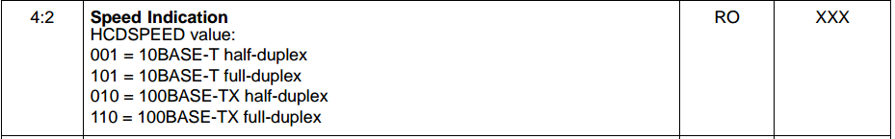

    - 配置config(PHY配置”顶半部分”)
> Device Drivers > Network Device/PHY Support
Board PHY Selection (ETH0) (SMSC LAN8742A PHY) --->

    - 配置config(网络配置)
> Networking Support
> Networking Support > Driver buffer configuration
(1518) Ethernet packet buffer size
(2) Driver I/O guard size

> Networking Support > Socket Support
(8) Number of socket descriptor
(16) Max socket operations
[*] Socket options
[*] SO_LINGER socket option

> Networking Support > TCP/IP Networking
[*] TCP/IP Networking
[ ] Disable TCP/IP Stack
[*] TCP/IP Keep-alive support
[ ] Urgent data
(8) Number of TCP/IP connections
(20) Number of listening ports
[*] Enable TCP/IP read-ahead buffering
[*] Enable TCP/IP write buffering
(32) Number of pre-allocated I/O buffer chain heads
[ ] Force write buffer debug
(0) TCP Rx delay
[*] TCP/IP backlog support
[ ] Optimized network sendfile()

> Networking Support > UDP Networking
[*] UDP Networking
[ ] Disable UDP/IP Stack
[ ] UDP Bind-to-device support
[*] UDP checksums
(8) Number of UDP sockets
[ ] UDP broadcast Rx support
[*] Enable UDP/IP read-ahead buffering
[*] Enable UDP/IP write buffering
(32) Number of pre-allocated I/O buffer chain heads
[ ] Force write buffer debug
> Networking Support > ARP Configuration
(16) ARP table size
(120) Max ARP entry age
[*] ARP address harvesting
[*] ARP send
(5) ARP send retries
(20) ARP re-send delay

[*] IGMPv2 client support
[*] Collect network statistics

> Networking Support > ICMP Networking Support
[*] Enable ICMP networking
[*] IPPROTO_ICMP socket support
(4) Max ICMP packet sockets

> Networking Support > Routing Table Configuration
[*] Routing table support
IPv4 routing table (In-memory) --->
(4) Preallocated IPv4 routing table entries

> Application Configuration > NSH Library > Networking Configuration
[*] Network initialization
[ ] Local network initialization
[ ] Network initialization thread
[ ] Network init debug
IP Address Configuration --->
[*] Hardware has no MAC address
MAC address selection (Fixed address) --->
(0x00e0deadbeef) Fixed MAC address
IP Address Configuration --->
(0xc0a80a1e) Target IPv4 address (0xc0a80a01) Router IPv4 address
(0xffffff00) IPv4 Network mask

SmartFS(QSPI FLASH)配置
    - 配置config(“底半部分”驱动)
> System Type > STM32 Peripheral Support
[*] QuadSPI

> System Type > QuadSPI Configuration
(16777216) Size of attached serial flash, bytes
(4) Number of bytes before asserting FIFO threshold flag
(1) Number of cycles Chip Select must be inactive between transactions
Transfer technique (Interrupts) --->
    - 配置config(“顶半部分”驱动)
> Device Drivers
[*] Memory Technology Device (MTD) Support --->
[*] Support MTD partitions
[*] Byte write
[*] QuadSPI-based Micron N25QXXX family FLASH
(0) N25QXXX QuadSPI Mode
(104000000) N25QXXX QuadSPI Frequency
[*] Sector Mapped Allocation for Really Tiny (SMART) Flash support
(1024) SMART Device sector size
[*] Support FLASH wear leveling
    - 配置config(SmartFS文件系统)
> File Systems
[*] SMART file system
(0xff) FLASH erased state
(16) Maximum file name length

> Application Configuration > File System Utilities
[*] mksmartfs utility

> Application Configuration > NSH Library > Disable Individual commands
[ ] Disable mksmartfs

    - 测试及使用方法:[Using SmartFS]

SD Card(SDIO)驱动配置
    - 新建文件
将stm32_sdmmc.c 拷贝到/nuttx/configs/board
主要是调用SDMMC的硬件初始化(底半部分)和设备初始化(顶半部分);
    - 修改makefile
在makefile下面追加:
ifeq ($(CONFIG_STM32F7_SDMMC1),y)
CSRCS += stm32_sdmmc.c
endif
    - 配置config(“底半部分”驱动)
> System Type > STM32 Peripheral Support
[*] SDMMC1

> System Type > SD/MMC Configuration
[ ] SDMMC transfer debug
[*] Support DMA data transfers
SDMMC1 Configuration --->
(0x00010000) SDMMC1 DMA priority
[ ] Use D1 only on SDMMC1
[ ] SDIO Card Support
[*] Enable internal Pull-Ups
    - 配置config(“顶半部分”驱动)
> Device Drivers > MMC/SD Driver Support
(1) Number of MMC/SD slots
[ ] Disable MMC/SD write access
[ ] Disable MMC/SD multiblock transfer
[*] MMC cards support
[*] MMC/SD card detect pin
[ ] MMC/SD write protect pin
[ ] MMC/SD SPI transfer support
[*] MMC/SD SDIO transfer support
[ ] SDIO bus share support
[ ] Use D0 Busy to detect Write Complete
[ ] SDIO 1-bit transfer
-*- SDIO block setup

- Bug记录

